Annex I (a): Co-financing letters

A. Co-financing letter from Ministry of Agriculture and Rural Areas


October 22, 2018
Adriana Dinu
GEF Executive Coordinator
United Nations Development Programme
One United Nations Plaza
New York, NY 10017, USA
Subject: Co-financing Commitment Letter for the UNDP supported, GEF financed project
"Strengthening coordinated approaches to reduce invasive alien species (IAS) threats to globally significant agrobiodiversity and agroecosystems in China"
Dear Ms. Dinu,
This letter confirms our co-financing commitment for the UNDP supported, GEF financed project "Strengthening coordinated approaches to reduce invasive alien species (IAS) threats to globally significant agrobiodiversity and agroecosystems in China", child project No. 2 under the PRC-GEF Partnership Program on Sustainable Agricultural Development.
We confirm USD 2.12 million (CNY 14.62 million, at an exchange rate Of 6.9) Of co-financing to ensure successful implementation of the project, through completion of complementary initiatives, active participation of our staff and provision of support services. Complementary initiatives.
We 100k forward to the commencement of the project.
Sincerely,
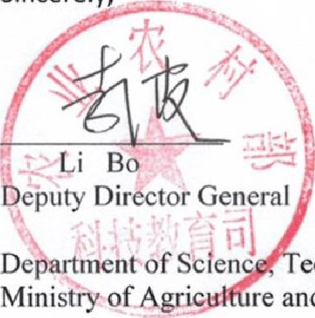
echnology and Education re and Rural Affairs
B. Co-financing letter Chinese Academy of Inspection and Quarantine.
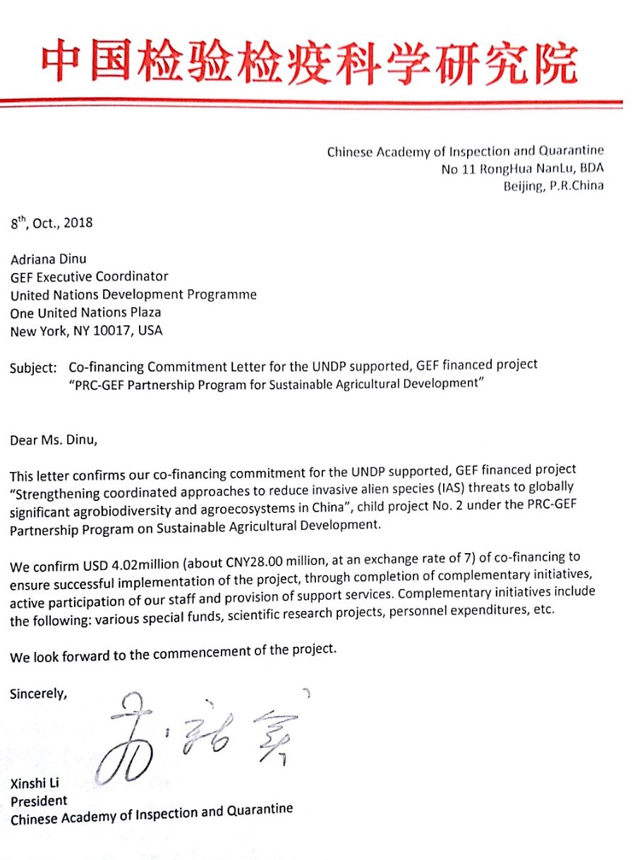

C. Co-financing letter from Ministry of Ecology and Environment.

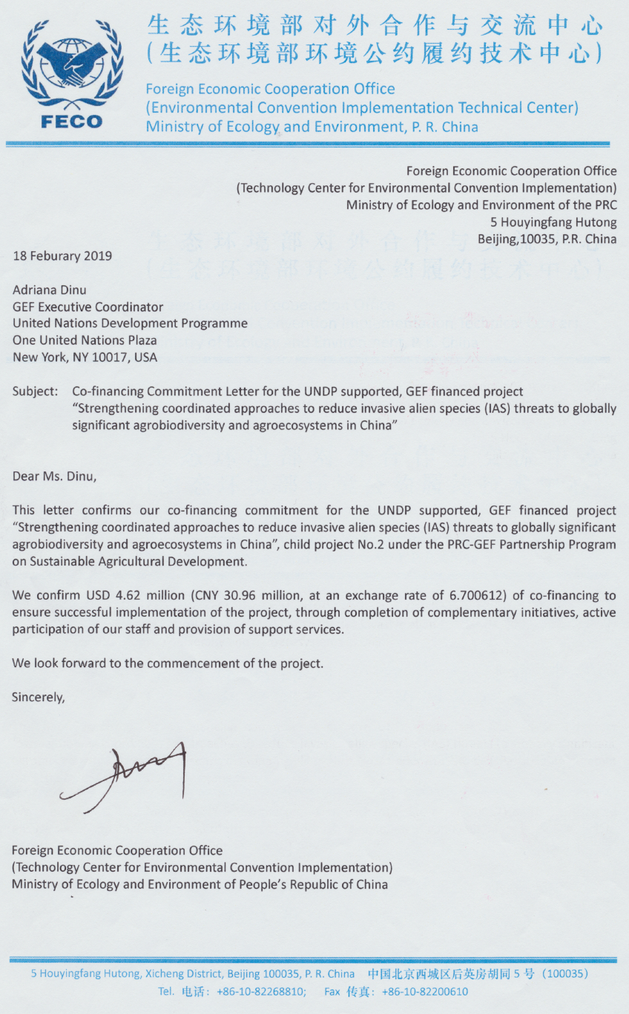
D. Co-financing letter from Chongqing Agriculture Department.

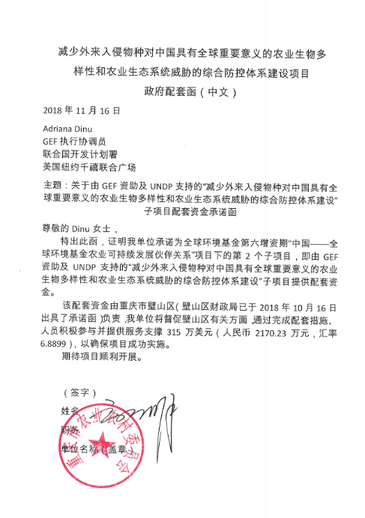

D. Translation co-financing letter from Chongqing Agriculture Department

16, October, 2018

Adriana Dinu
GEF Executive Coordinator
United Nations Development Programme
One United Nations Plaza
New York, NY 10017, USA

Subject: Co-financing Commitment Letter for the UNDP supported, GEF financed project
“Strengthening Coordinated Approaches to Reduce Invasive Alien Species (IAS) Threats to Globally Significant Agrobiodiversity and Agroecosystems in China”

Dear Ms. Dinu,

This letter confirms our co-financing commitment for the UNDP supported, GEF financed project “Strengthening Coordinated Approaches to Reduce Invasive Alien Species (IAS) Threats to Globally Significant Agrobiodiversity and Agroecosystems in China”, child project No. 2 under the PRC-GEF Partnership Program on Sustainable Agricultural Development.

We confirm USD 3.15 million (CNY 21.7023 million, at an exchange rate of 6.8899) of co-financing to ensure successful implementation of the project, through completion of complementary initiatives, active participation of our staff and provision of support services.

We look forward to the commencement of the project.

Sincerely,

Mr.Peng Luyou
Deputy Director

E. Co-financing letter (translation) from Hainan Agriculture Department.
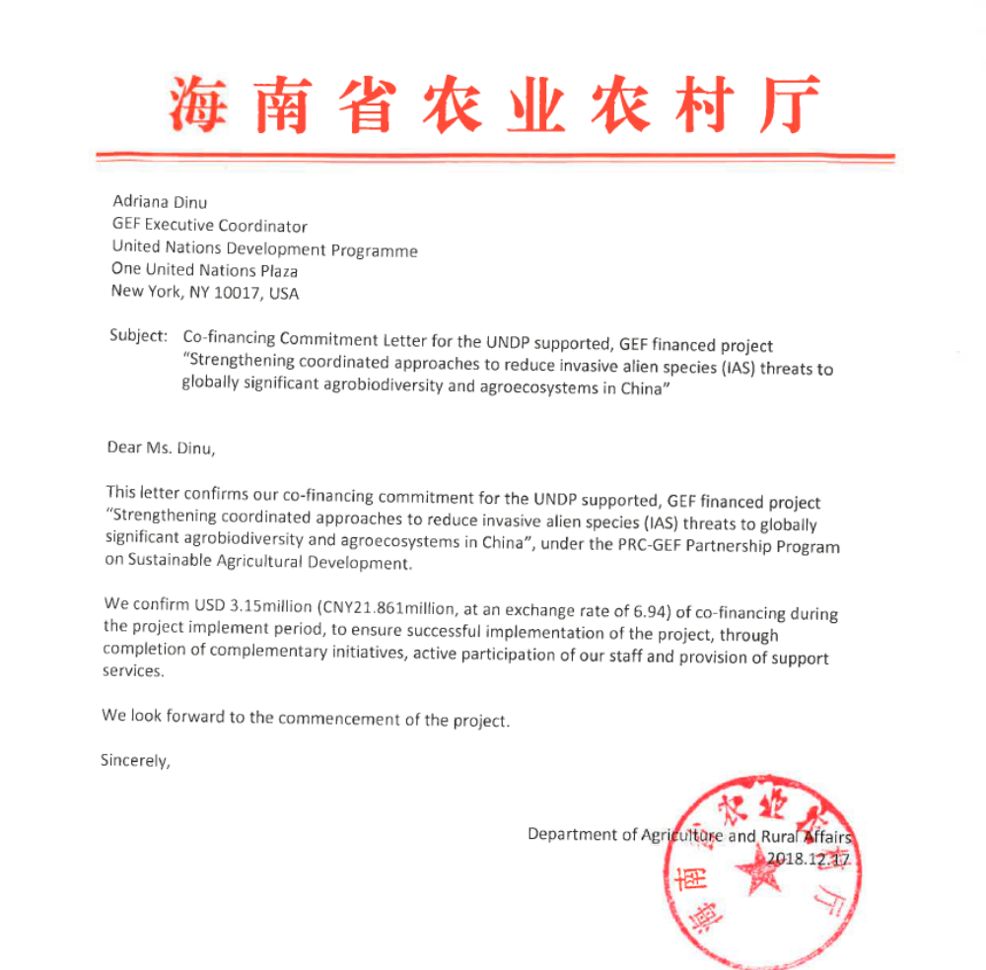

F. Co-financing letter from Chongqing Late Orange Planting Farmers’ Cooperative.

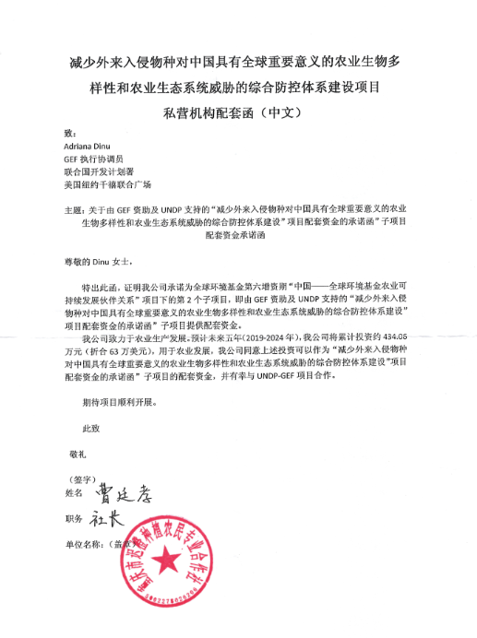

F. Translation Co-financing letter from Chongqing Late Orange Planting Farmers’ Cooperative.

16, October, 2018

Adriana Dinu
GEF Executive Coordinator
United Nations Development Programme
One United Nations Plaza
New York, NY 10017, USA

Subject: Co-financing Commitment Letter for the UNDP supported, GEF financed project
“Strengthening Coordinated Approaches to Reduce Invasive Alien Species (IAS) Threats to Globally Significant Agrobiodiversity and Agroecosystems in China”

Dear Ms. Dinu,

This letter confirms our co-financing commitment for the UNDP supported, GEF financed project “Strengthening Coordinated Approaches to Reduce Invasive Alien Species (IAS) Threats to Globally Significant Agrobiodiversity and Agroecosystems in China”, child project No. 2 under the PRC-GEF Partnership Program on Sustainable Agricultural Development.

Our company is committed to agricultural production development. We expect that our cumulative investments over the next five years 2019-2024 will be approximately CNY 4.34 million (USD 0.63 million), focused on agricultural development in the county. We confirm that these investments can be considered as co-financing for the proposed UNDP supported, GEF financed project. We are very interested in working together with the UNDP-GEF project in strengthening coordinated approaches to reduce invasive alien species (IAS) threats to globally significant agrobiodiversity and agroecosystems in China.

We look forward to the commencement of the project.

Sincerely,

Mr.Cao Tingxiao
President

G. Co-financing letter from Wenchang Wenting Agritourism and Ecological Agriculture Co. Ltd.
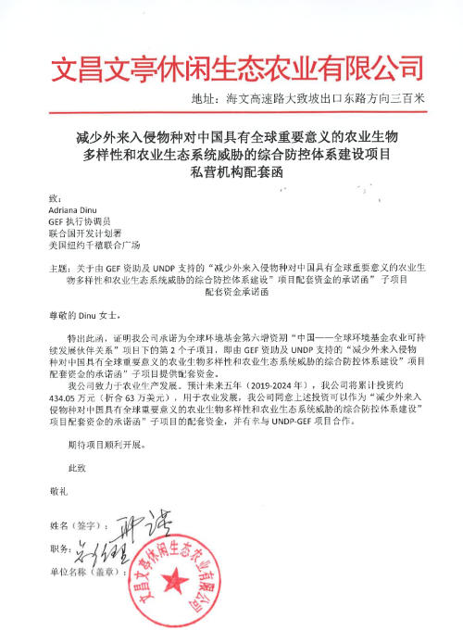

G. Translation Co-financing letter from Wenchang Wenting Agritourism and Ecological Agriculture Co. Ltd.

1, December, 2018

Adriana Dinu
GEF Executive Coordinator
United Nations Development Programme
One United Nations Plaza
New York, NY 10017, USA

Subject: Co-financing Commitment Letter for the UNDP supported, GEF financed project
“Strengthening Coordinated Approaches to Reduce Invasive Alien Species (IAS) Threats to Globally Significant Agrobiodiversity and Agroecosystems in China”

Dear Ms. Dinu,

This letter confirms our co-financing commitment for the UNDP supported, GEF financed project “Strengthening Coordinated Approaches to Reduce Invasive Alien Species (IAS) Threats to Globally Significant Agrobiodiversity and Agroecosystems in China”, child project No. 2 under the PRC-GEF Partnership Program on Sustainable Agricultural Development.

Our company is committed to agricultural production development. We expect that our cumulative investments over the next five years 2019-2024 will be approximately CNY 4.3405 million (USD 0.63 million), focused on agricultural development in the county. We confirm that these investments can be considered as co-financing for the proposed UNDP supported, GEF financed project. We are very interested in working together with the UNDP-GEF project in strengthening coordinated approaches to reduce invasive alien species (IAS) threats to globally significant agrobiodiversity and agroecosystems in China.

We look forward to the commencement of the project.

Sincerely,

Xing Jin
General Manager

H. Co-financing letter (translation) from Beijing Huaheng Rongtong Technology Co. Ltd.
